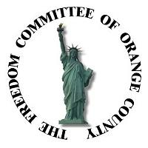
The Freedom Committee of Orange County
Neighborhood Community Center
1845 Park Ave., Costa Mesa, CA. 92627

Minutes of the Meeting of January 12, 2011
Pledge of Allegiance:

Invocation: Frank Orzio

Guests Present: (12) Mike Akland, Frank Callahan, Kathleen Felix, Wendy Leece, Mickey Lukes, Jan Moorhead, Jon Pelanne, Ray Stoddard, Paul Turgeon and Ray Wong. + (2 unknown guests)
Members Present: (65) Jim Baker, Vic Bakkila, Bob Bankston, Betty Bell, Jess Carranza, Jack Cole, Robby Conn, Bus Cornelius, Bob Cowley, Roberta Cowley, Jeff Davis, Bob Dugan, Eddie Felix, Kirk Ferguson, Francis Flacks, Marty Flacks, Dan Gillespie, Ray Grissom, George Grupe, Ronnie Guyer, Frank Haigler, Sid Hallburn, Jack Hammett, Arnold Hanson, Dale Hanson, Ramona Hill, William Holiday, Art Lambert, Jess Lawson, David Lester, Frank Mannino, Ted Marinos, Vern Martin, Robert Meyer, Charles Mitchell, Dick O’Brien, Don Oldis, Frank Orzio, Sherrie Orzio, Bob Perry, Lou Possemato, Harry Rawlins, Gladys Refakes, Tim Richards, Larry Schnitzer, Terry Schnitzer, Harry Selling, Judy Selling, John Skara, Martha Somers, Duke Steinken, Bob Sternfels, Bob Stoddard, Ted Tanner, Bob Thomas, Allan Thompson, Phillip Vinci, Gene Wallace, Linda Wallace, Denise Weiland, Fred Whitaker, Paul Wilder, Scott Williams, Sid Yahn and Elizabeth Yee.
Special Presentation

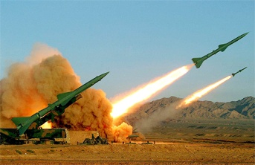
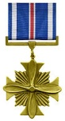
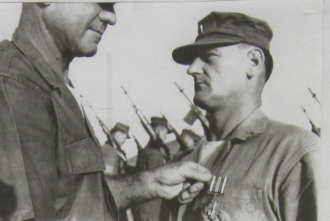
W. T. “Duke” Steinken, Captain, USMC (Ret.) who served in WWII, Korea, Cuba, and two tours in Vietnam, recalled part of his military career as a Marine Aviator in Vietnam. When the Soviet Union agreed to provide air defense missiles to North Vietnam in July 1965, the “flying telephone poles” referred to as SAMs (Surface to Air Missiles) were fired at our F4C Phantom fighter bombers. This was in addition to the anti-aircraft gun batteries. The S-75 missile was capable of destroying targets at an altitude of 27 kilometers and a range of 35 kilometers, thus giving it a kill radius of approximately 63 meters.
Distinguished Flying Cross
The SAM Batteries had unique radar, labeled by NATO
as Fan Song. This was an acquisition and firing radar and had an Achilles Heel in that the SAM had to be manually maneuvered to the target. To counter the Soviet missiles, the US employed the Douglas EF-10B ‘Sky Knight’ with special Electronic Missile Suppression instruments and a crew of a pilot and ECM Operator. (Electronic Counter Measures) Flying in a relative slow, straight-winged jet, (360 MPH)
SAM Missile battery
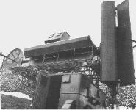
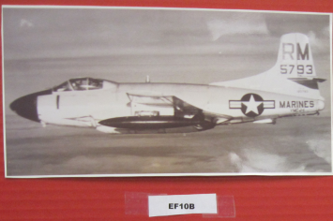
EF-10B “Sky Knight”
Electronic Counter- Measures

Soviet Fan Song radar

armed with 2 20mm machineguns, Duke’s mission was to tune in to the Fan Song radar when it first turned on and then jam the radar and dispense chaff (metal strips cut to a certain length) to cloud the radar returns. And like all the other aircraft, dodge SAM missiles. In 1965 the Marines provided the ECM aircraft for all the Navy and Air Force planes. The effectiveness of the ECM in Vietnam War is illustrated by the facts.
1965 missiles fired | 109 | Aircraft lost = 11 | Missiles/aircraft 9.9
1972 missiles fired | 2,059 | Aircraft lost = 73 | Missiles/aircraft 27.2
Vietnam War 65-72 | 5,804 | Aircraft lost = 197 | Missiles/aircraft 26.6
During the Vietnam War, the Soviet Union supplied North Vietnam with 95 combat batteries of the SA-75 missiles, of which 56 were destroyed. No numbers of Soviet “SAM instructors” killed have been released.
A personal side light was the combat experience of Ronnie Guyer, a FCOC member and a former member of the 1st Air Cav. Division, (Airmobile). During a battle in the I Drang Valley, near Plei Me, his unit had to declare a “Broken Arrow”; American unit in danger of being overruns the Communist North Vietnamese. Duke’s Marine Air Squadron responded and dropped bombs and prevented that from happening.

Table Topics

- Jack Hammett announced that he is making a Legacy DVD of WWII that can be used in the schools.
- Fred Whitaker suggested that a brochure of the Freedom Committee explaining our purposes and goals be made. These could be handed out at the Marching Through History Event.
- Donations to the Freedom Committee are coming in. tpt home donated $500 and Harbor Lawn Cemetery donated $500.
- Jack Hammett announced that the FCOC was represented at the January 11th swearing- in of the Orange County Supervisors. Attending were Jack Hammett, Scott Williams, Fred Whitaker, Larry Schnitzer, Bus Cornelius, Dick Higgins and Tim Richards. MOH Walter Ehlers lead the Pledge of Allegiance.
- Charles Mitchell announced that seven Police Officers that served in Iraq will be honored February 2nd.
- Larry Schnitzer, FCOC Treasurer, reported December balance of $5266. An annual audit of FCOC financial records is in progress.
- Jack Hammett reported on the 69th Pearl Harbor Remembrance that he and Larry Schnitzer attended on December 7th in Hawaii. He stated there are about 3,700 Pearl Harbor Survivors alive out of an original 84,000. The Commanding Officer of the Pacific Fleet made remarks as did the Mayor of Honolulu. All Pearl Harbor Survivors that attended were upgraded to First Class on the air flights.

(Minutes of the meeting prepared by Tim Richards)
Jack Hammett

