**FREEDOM COMMITTEE OF ORANGE COUNTY**

***“Passing the Torch of Liberty On To Future Generations”***

***Neighborhood Community Center***

***1845 Park Ave., Costa Mesa, CA. 92627***

June 8, 2011 Meeting Agenda

Web Site – [**http://www.fc-oc.org**](http://www.fc-oc.org/)

**GATHERING @ 11:30 A.M.**

**Meeting Starts at Noon.**

**Pledge of Allegiance:**

**Invocation: Pastor Frank Orzio, Sgt. USMC (Ret.)**

**Taps: Capt. William T. “Duke” Steinken, USMC (Ret.)**

**Binnacle List: Ed Decker**

**Introduction of Guests:**

**Member Introductions:**

***Special Presentation***

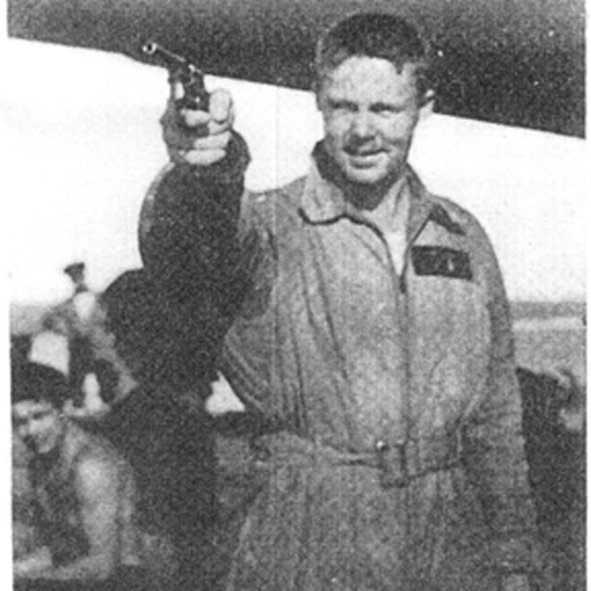 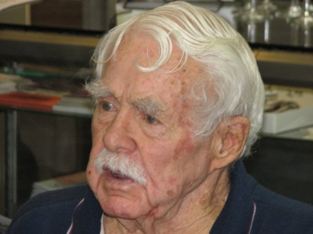

Air Medal RibbonAmerican Campaign Medal Ribbon  
Asiatic Pacific Campaign Medal - WWII RibbonWorld War II (WWII) Victory Medal RibbonPhilippine Liberation Medal Ribbon - World War II

**Daniel D. Huston, Lt. USN, WWII**

**Battleship Scout Pilot, USS Colorado**

**Asiatic-Pacific, 10 Combat Stars**

**“*Flying the King Fisher, The Eyes of the Fleet”***

**Jack Hammett: “Pacific Historic Parks (PHP) Program”**

**Guam, Saipan, Kaulapapa, Oklahoma & Utah Memorials**

**Scott Williams:**Administrative Reports:

* Tax exempt progress
* FCOC Memorial Day participation

**Bette Bell***:* Financial Report

**Denise Weiland:** School Speakers Report

***Table Topics***